**I. Using Matlab [60%]**

* 1. Describe the result of each of the following Matlab commands.
     1. >> x = randperm(5);

Answer : Return a row vector which contains a random permutation of 1 to 5.

Result : x = [2, 3, 4, 5, 1]

* + 1. >> a = [1:10];

>> b = a([1:3:end]);

Answer : Allocated a row vector containing integer from 1 to 10. Second line means that picking elements of ‘a’ starts with index 1, traces 3 steps to be next, and traces to the end.

Result : a = [1, 2, 3, 4, 5, 6, 7, 8, 9, 10].

b = [1, 4, 7, 10].

* + 1. >> f = [1501:2000];

>> g = find(f > 1850);

>> h = f(g);

Answer : Allocated a row vector containing integer from 1501 to 2000. Second line is returning a row vector which contains all the indices of elements which are greater than 1850 in ‘f’. Third line is selecting elements of ‘f’ by indices which are elements of ‘g’.

Result : f = [1501, 1502, 1503, …, 1999, 2000].

g = [351, 352, 353, …, 498, 499, 500].

h = [1851, 1852, 1854, …, 1999, 2000].

* + 1. >> x = 22.*ones(1,10);

>> y = sum(x);

Answer : Allocated a matrix 1*10 and all elements are one. Then every element is multiplied by 22. Second line, sum all of the elements in x.

Result : x = [22, 22, 22, 22, 22, 22, 22, 22, 22, 22].

y = 220

* + 1. >> a = [1:1000];

>> b = a([end:-1:1]);

Answer : Allocated a row vector containing integer from 1 to 1000. Second line select elements of ‘a’ by indices from the end to the first.

Result : a = [1, 2, 3, 4, …, 997, 998, 999, 1000].

b = [1000, 999, 998, 997, 996, … 4, 3, 2, 1].

1. 3 Given a 100 x 100 uint8 matrix A representing a grayscale image.

1. Sort all the intensities in A, put the result in a single 10,000-dimensional vector x, and plot the values in x.

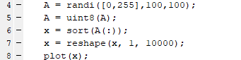

1. Display a figure showing a histogram of A’s intensities with 32 bins.



1. Create and display a new binary image the same size as A, which is white wherever the intensity in A is greater than a threshold t, and black everywhere else.

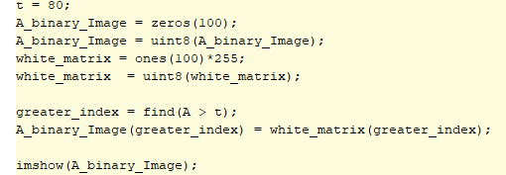

1. Generate a new image, which is the same as A, but with A’s mean intensity value subtracted from each pixel. Set any negative values to 0.



1. Use rand to write a function that returns the roll of a six-sided die.



1. Let y be the vector: y = [1:6]. Use the reshape command to form a new matrix z whose first column is [1, 2, 3]’, and whose second column is [4, 5, 6]’.



1. Use the min and find functions to set x to the single minimum value that occurs in A, and set r to the row it occurs in and c to the column it occurs in.

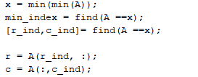

1. Let v be the vector: v = [1 8 8 2 1 3 9 8]. Use the unique function to compute the total number of unique values that occur in v.



**II. Programming problem: averaging images [40%]**